PROBLEM STATEMENT
Making of cart system
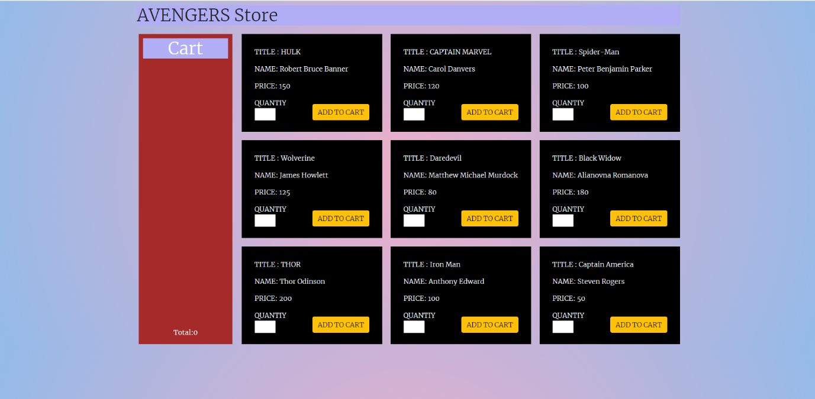
OUTPUT
\

Here all the data is coming from the database and storing in each div as a card
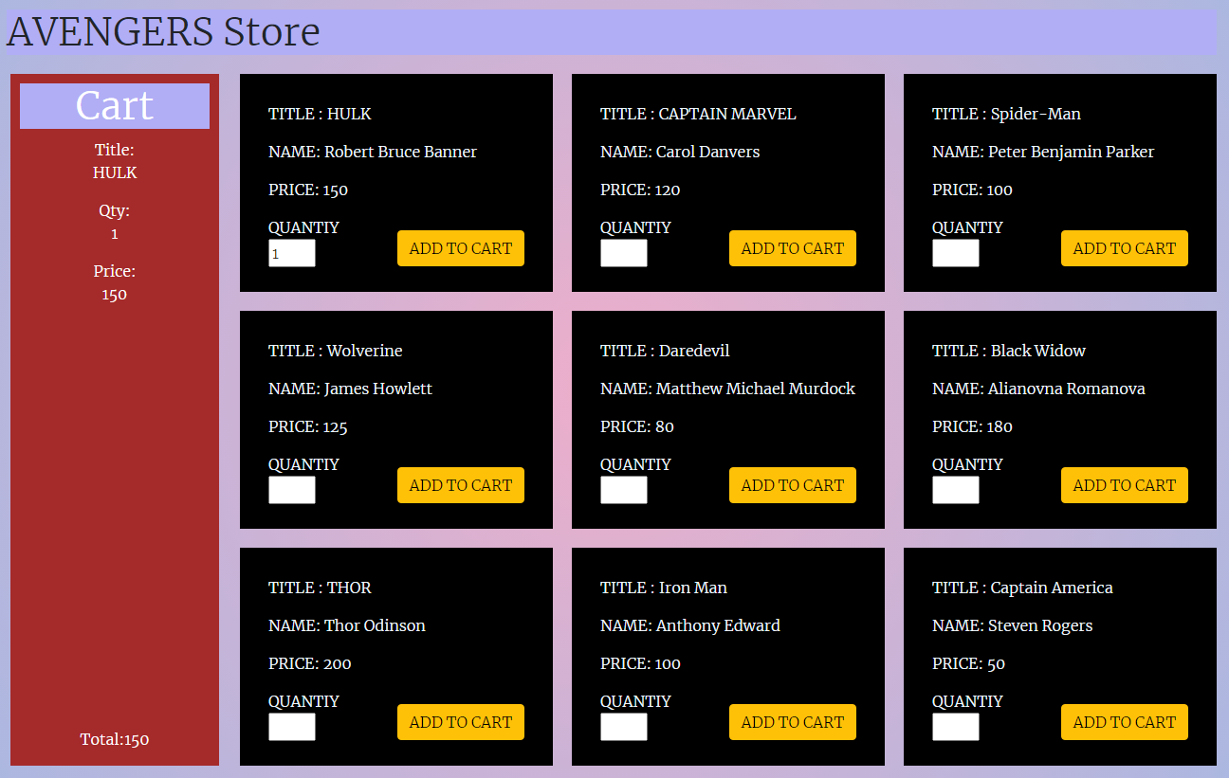

When the user set the quantity then click on add to cart , the products get added to the cart
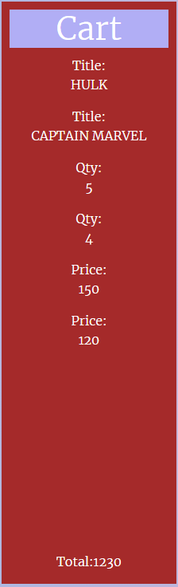
Here it is showing multiple hero with specified quantities with the total amount

